International Association for Statistical Education
November 2001
 | Editorial Address | Susan Starkings, Learning & Development Centre, South Bank University, Borough Road,  London SE1 0AA, United Kingdom.  Tel: +44 (0) 20 7815 7455 – Fax: +44 (0)20 7815 6464 – E-mail: starkisa@vax.sbu.ac.uk
 | President | Carmen Batanero, Department of Mathematics Education, Faculty of Education,  University of Granada, Campus de Cartuja, 18071 Granada, Spain.  Tel: +34 958 243950 – Fax: +34 958 246359 – E-mail: batanero@ugr.es  Web site: http://www.ugr.es/local/batanero
 | Website | http://www.cbs.nl/isi/iase.htm

Message from Carmen Batanero, President IASE

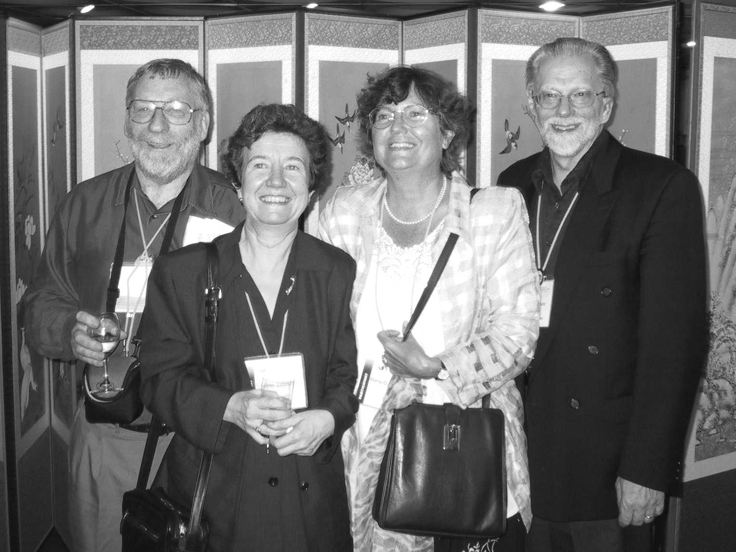  Four IASE Presidents at ISI–53 | It is for me a very great honour to take over the role of IASE President. I would like to start these words by thanking all of you for your confidence and by expressing my gratitude to all the 1999–2001 IASE Executive Committee members: Brian Phillips, Dani Ben-Zvi, Joan Garfield, Lionel Pereira-Mendoza,
Gilberte Schuyten, M. Gabriella Ottaviani, Susan Starkings and Tae Rim Lee, who devoted so much time and effort to improve the IASE functioning and extend their activities. These have been two very successful years for the IASE, in which we held important statistics education conferences and increased the number and quality of our publications. It also has been noticeable the greater collaboration with other institutions, the updating of our National Correspondent Network, the improvement of our web site and our increasing participation in ISI tasks.
I heartily welcome and thank the new Executive committee, the President Elect Chris Wild, past President Brian Phillips, Vice-presidents Dani Ben-Zvi, Carol Joyce Blumberg, Lisbeth Cordani, Gilberte Schuyten and Susan Starkings, as well as the co-opted members Gail Burrill, Delia North, and M. Gabriella Ottaviani, for accepting the challenging task of trying to improve the association in the next two years. It is reassuring to be able to count on such a good team of colleagues to provide advice and support and to help me in guiding the association and in carrying out its many tasks.
We enter this new period with a strong and healthy association and with a number of plans to continue our work. Next year we celebrate our ICOTS–6 Conference in Durban South Africa. Most of us work in isolation or in small groups in different departments and institutions. At the ICOTS conferences, we have the opportunity to meet other colleagues from around the world during a week, to share our experiences with them, plan collaborative projects and feel that the ideal of University is also possible for statistics education. By now the ICOTS-6 Programme is almost finished thanks to the excellent work by the IPC Committee, and in particular to the efforts by Gabriella Ottaviani, Brian Phillips, and Dani Ben-Zvi. Our local organisers chaired by Delia North are doing their best to receive us and make us feel at home while in South Africa. I encourage you not to miss this event and contribute to a memorable conference.
We are also working to prepare our program for ISI–54, Berlin, 2003. Gilberte Schuyten our representative at the ISI Coordinating Committee for Berlin has organised a wide and varied proposal of topics for Invited Paper Meetings, both organised by the IASE alone and in conjunction with other ISI Sections and Committees and in brief we will announce the topics and organisers. In 2004 the ICME-10 Conference will be held in Copenhagen. Conversations were held by Brian Phillips with Morgen Niss the chief organiser of ICME-10 to help in organising some statistical education activities, with Joe Wisenbaker as our representative for this organisation. In this same year we will celebrate our next IASE Round Table Conference near Copenhagen. The theme of the conference will be “Curricular Development in Statistics” and Gail Burrill (gburrill@nas.edu) will be the Conference Chair.
We are still looking for an adequate venue for this conference. We are also starting to think about ISI-55, to be held in 2005, Sidney and Chris Wild (c.wild@auckland.ac.nz) has agreed to represent the IASE at the ISI Programme Coordinating Committee for Sydney. Chris needs to start thinking about possible themes and organisers for the IASE Invited Papers Meetings and he would welcome any good ideas for new themes to present at this Programme. We are also working towards the first steps in the organisation of our ICOTS-7 conference in 2006. Within the incoming IASE Executive Lisbeth Cordani will be responsible to continue our previous work on this theme.
We plan to continue our publications, including IASE representative to the editorial board of the International Statistical Review (Chris Wild), IASE matters (Gilberte Schuyten), IASE Review (Carmen), IASE pages in ISI Newsletter (Susan Starkings) and the Statistics Education Research Newsletter (SERN).
Chris Reading will be entering the SERN team with Gabriella Ottaviani and Carmen Batanero. Carol Joyce Blumberg and I will coordinate communications between our publications to make the best use of our publications and increase their interest to our audiences. Anyone wishing to submit information for IASE publications who is not sure which publications are appropriate for their information, may contact either Carol (cblumberg@winona.edu) or me and we will assist you in disseminating your information in the proper publications. Brian Phillips will continue maintaining our web site, which is now one main resource for statistics education. We would like to thank Joan Garfield for all her work in our different publications in the last years, including the role of associate editor in ISR, the SERN newsletter and the IASE pages in ISI Newsletter.
In this new period we plan to start working on the World Numeracy Project. Carol Blumberg, in her role as one of the IASE Vice-Presidents and as part of her sabbatical year, will continue the work of the previous ISI World Numeracy Programme Committee by analysing possible ideas for IASE and ISI activities in this area and by organising a standing committee. She would welcome any help or ideas. See the separate article on the World Numeracy Project elsewhere in this issue of ISI Newsletter.
The IASE is now 10 years old and even when we are getting stronger each year we can still grow. It is most important to increase our membership, since there are still many statistics educators who are not members and who can give and receive benefits from and to the IASE. Although we all will be trying to contact potential new members and we also count with the help of all the IASE members in this task, Susan Starkings and Lisbeth Cordani will be specially devoted to membership issues. We also plan to continue and to extend our policy of collaboration with other associations and professional bodies interested in statistics education in order to organise conferences, working groups or joint publications. Dani Ben-Zvi will serve as a link with mathematical education societies and I will be the contact with statistical societies. Brian Phillips will continue to coordinate the National Correspondents Network.
Finally we think it is important to increase our presence in the ISI itself and to participate in its Committees. By now there are still a small percentage of IASE members in ISI, and we feel that we are underrepresented as compared with other ISI Sections. Since ISI members must be nominated, it is important that IASE members who deserve it be nominated each time there are elections for ISI membership. We think there are potential ISI members in our association, and it is important to organise a Committee that looks for these people and prepare a nomination proposal. Helena Bacelar, who is an IASE and ISI member has agreed to organise this committee and start its functioning.
From this summary of our plans for the next two years, you can see that this will be another very busy and challenging period. We are lucky to count with a larger Executive Committee than in previous period as well as with members of the past Executive and members outside the Executive who are willing to work for the IASE in the next two years. Many other people are willing to serve the IASE as National Correspondent in their countries, and as organisers of sessions for next ICOTS-6 Conference or ISI–54 Session, speakers or reactors in our conferences, in providing information for our publications and in getting new members. We hope to continue receiving your help in all these tasks in the next period, since it is only with the help of all members that IASE can become a strong association. Electronic mail now makes communication easier. We will also be very glad in receiving your feedback at any time you have an idea to improve the IASE functioning or you want to get more information about our work.
IASE Invited Papers Meetings at the ISI, 53rd Session
There were seven sessions organised by the IASE alone, with another four being jointly organised with other Sections. Lionel Pereira-Mendoza (lpereira@nie.edu.sg) was co-ordinating our section of the programme.
IASE Organised Sessions
IPM 55.
Forum: IASE and Statistics Education in Developing Countries.
Organizer:
Maria-Gabriella Ottaviani (ottavian@pow2.sta.uniroma1.it)
Papers:
Youri Ivanov (delivered by M. Gabriella Ottaviani):
Selected aspects of education in statistics in Russia
Ana Silvia Haedo:
An overview on the teaching of statistics at schools and university in Argentina
Munir Ahmad (delivered by Saleha N. Habibullah):
On fifty years of university and pre-university teaching of statistics in Pakistan
Koffi N’Guessan:
L’Ensea, 40 ans au service de la formation statistique en Afrique
IPM 56.
Undergraduate Level Statistics Programmes.
Organizer: Shen Shir Ming (smshen@hkuspace.hku.hk)
Papers:
Ann-Lee Wang:
Introducing Markov chains models to undergraduates
Tony W.K. Fung:
Teaching undergraduate statistics using forensic example
Susan Starkings, & Jerome Healy:
The pre-requisite knowledge required by students starting data analysis classes at university
C. R. Rao:
Developing the curriculum of undergraduate courses in statistics: Indian and American experiences
Discussants: J.L. Rosenburger.
IPM 57
The Future of Statistics Education Research.
Organizer: Joan Garfield (jbg@maroon.tc.umn.edu)
Chair: Roxy Peck
Papers:
Carmen Batanero, & Juan D. Godino:
Developing new theoretical tools in statistics education research
Flavia Jolliffe:
An international survey of research in statistical education
Beth Chance & Joan Garfield:
New approaches to gathering data on student learning for research.
Discussants: Gilberte Schuyten and Maria-Gabriella Ottaviani.
IPM 58
Research on Teaching Statistics at School and University Levels.
Organizer: Susan Starkings (starkisa@sbu.ac.uk)
Papers:
Maria Pannone, Anna Maria Milito, & Silio Rigatti Luchini:
New strategies for teaching statistics at school
Dani-Ben Zvi, & Abraham Arcavi:
Developing expert’ points of view on local-global approaches to data and data representation
James Nicholson & Gerry Mulhern:
Supporting statistics teaching and learning at A-level: Using computer based materials
Discussant: Flavia Jolliffe.
IPM59
Undergraduate Statistics Education in Non-Statistics Degree Programmes.
Organizer: Elisabeth Svensson (elisabeth.svensson@esa.oru.se)
Papers:
Kerstin Wiklander:
Teaching statistics in pre-clinical and pharmaceutical departments
Carol Joyce Blumberg:
Is there life after introductory statistics?
Discussant: P K Ito.
IPM60
Continuing Statistics Education in the Workplace.
Organizer: Carol Joyce Blumberg, (cblumberg@winona.edu)
Papers:
Kenneth J. Koehler & W. Robert Stephenson:
Statistical education outreach = unlimited learning
Elizabeth A. Taylor:
The Challenges for Providers of International Statistical Training
Maarten Boon:
Recent E-Learning initiatives related to the international training in official statistics.
Discussants: Réne H. M. Smulders and Ryoichi Shimizu
IPM61
Postgraduate Training of Statisticians.
Organizer: Gilberte Schuyten (Gilberte.Schuyten@rug.ac.be)
Papers:
Seymour Geisser:
Observations on graduate programs in statistics II
Brian Phillips:
Report on the IASE Round Table Conference on The Training of Researchers in the Use of Statistics
Yuki Miura:
Training of statisticians in Japan.
Discussant: Els Goetghebeur
Joint IASE Sessions
IPM10.
Technology in Statistical Education.
Joint with IASC.
Organizer: Tae Rim Lee (trlee@av9500.knou.ac.kr)
Papers:
Jung Jin Lee & Gunseog Kang:
An educational software for the design of experiments
Martha Bilotti Aliaga:
Information is not knowledge: the information revolution
Kay Lipson:
Ongoing individualised students assessment using the Internet
Naoko Sakurai, Michiko Watanabe, Kazunori Yamaguchi, Akinobu Takeuchi, Katsuyuki Suenaga, Hiroshi Yadohisa, & Chooichiro Asano.
Interactive education system for learning statistics on the Internet.
Discussants: Masakasu Murakami and Joongkweon Shon.
IPM11
Women's Contributions to Leadership in Statistical Education.
Joint with CWS.
Organizer: Martha Aliaga (Aliaga@Umich.Edu)
Papers:
Tae Rim Lee:
The Role of the Internet in statistical education
Pilar L. Iglesias & Gloria Icaza:
Leadership research in teaching and learning statistics in Chile
Shyamala Nagaraj:
Women's role in shaping future directions in statistical education
Elsa C. Servy:
Statistical education at the National University of Rosario, Argentina
Discussants: Mary H. Regier, & Mary Gray.
IPM14
The Role of Official Statistics in University Curriculum
Joint with IAOS.
Organizer: Reiner Staeglin (rstaeglin@diw.de)
Papers:
Erkki Pahkinen & Risto Lehtonen:
Masters’ programmes in statistics as a platform for cooperation between university and official statistics
Sibylle Schmerbach:
Official statistics in Gernan university education
Carmen Feijo:
An approach to the teaching of social accounts in the Brazilian university curricula.
Discussant: Ernst Stadlober.
IPM15
Education and the Internet & Effective Structures for the Net.
Joint with IAOS.
Organizer: Brian Phillips (bphillips@swin.edu.au)
Papers:
Larry Weldon:
Statistical education with official statistics on the Internet
Photis Nanopoulos:
Distance learning: Eurostat’s activities

IASE Satellite Conference on Statistical Literacy
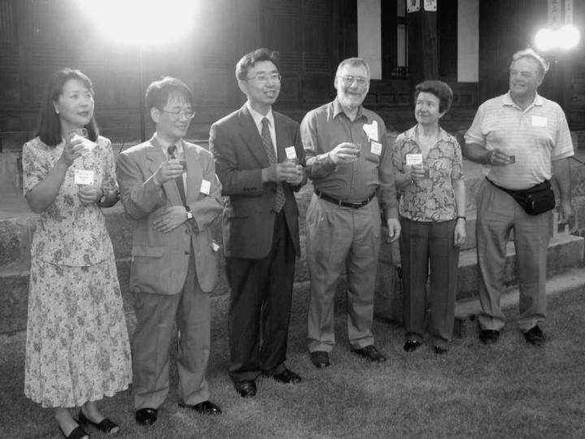
The ISI–53 Session in Seoul was preceded by a satellite conference on statistical literacy which was jointly organised by the IASE and the Korean Statistical Society and immediately preceded the ISI Session in Seoul in August, 2001. The Program Chair was Brian Phillips (Australia) and Professor Yong Goo Lee (Korea) was the Local organiser. About 60 participants from 16 countries attended this most enjoyable and worthwhile program on statistical literacy.
Organisers of Satellite workshop at the garden dinner
The talks at the conference gave a wonderful opportunity for participants to gain ideas for developing statistical literacy. We are very thankful to our Korean hosts, especially Lee Yong Goo, for their wonderful hospitality including a tour in a Korean Tradition Street and a wonderful dinner in the garden of the private home of the former President of Korea. Having a small focussed meeting was an excellent prelude to the large ISI conference as participants were able to establish relationships before being immersed in a meeting with some 2,500 people. It is planned that proceedings of the talks will be produced. All details, along with some of the presentations, a list of participants and a photo gallery of the activities is available on the web site
Papers presented:
Larry Weldon (Canada)
Probability in First Service Course.
Ricardo Aravena, Guido del Pino, & Pilar Iglesias (Chile)
Explora: A Chilean Science and Technology Outreach Program in Probability and Statistics.
Yong Goo Lee (Korea)
Teaching Statistical Concepts in the Elementary School.
James Nicholson (UK)
Outcomes of a Teaching Experiment.
Saleha Naghmi Habibullah (Pakistan)
'KISC' and 'CODAK': An Indirect yet Effective way of Promoting Statistical Thinking in the General Community of Students and Teachers.
Nick Broers (The Netherlands)
From Propositional Knowledge To Conceptual Understanding Of Elementary Statistics.
Jung Jin Lee and Gunseog Kang (Korea)
An Educational Software for the Design of Experiments.
Elizabeth Taylor (USA)
The Graphical Presentation of Data in Every Day Life.
Juan D. Godino and Carmen Batanero (Spain)
Training Teachers To Teach Probability.
Shrikant I. Bangdiwala (USA)
Teaching Statistical Reasoning in Elementary Schools using Age-appropriate Methods.
Beth Chance and Roxy Peck (USA)
Workshop on Statistics of Illumination.
David Moore (USA)
Statistical Literacy and Statistical Competence
Stephen Clarke (Australia)
Can statistics demonstrate a Home advantage in the Olympic games?

Training Researchers in the Use of Statistics Book
The Round Table Conference on The Training of Researchers in the Use of Statistics was held at the Institute of Statistical Mathematics in Tokyo, August 7–11, 2000 and was sponsored by the IASE and the ISI, the Institute of Statistical Mathematics and the Japan Statistical Society. In 2001 a book was published with the conference papers and discussions. We hope this book will serve as a starting point for other lecturers, researchers and statistics educators to change their teaching approaches, to improve the interest to collaborate in applied research and to start new didactical research on the statistical training of researchers in empirical sciences.
Book reference:
Training Researchers in the Use of Statistics
IASE Round Table Conference, Tokyo 2000
Edited by Carmen BATANERO
ISBN 90-73592-19-4
Published by:
International Association for Statistical Education
International Statistical Institute
Available from:
ISI Permanent Office, 428 Prinses Beatrixlaan, P.O. Box 950, 2270 AZ Voorburg, The Netherlands
Price: US$25, including postage.


The Sixth International Conference on Teaching Statistics

Durban, South Africa, 7 – 12 July 2002
IPC Website: http://www.beeri.org.il/icots6
LOC Website: http://icots.itikzn.co.za/
The preparations for the Sixth International Conference on Teaching Statistics (ICOTS–6) are well under way. The Conference is organized by the IASE, the ISI and the South African Statistical Association (SASA). ICOTS-6 will take place in Durban (South Africa) from July 7–12, 2002. As the conference theme for ICOTS–6 is ‘Developing a statistically literate society’, special sessions on statistical literacy are planned. A full description of all details for preparing ICOTS-6 papers, including periodic updates of the scientific programmes and papers abstracts is available in the ICOTS–6 IPC website http://www.beeri.org.il/icots6/
Authors have the option of a full paper refereeing process for those who desire it. The refereeing process provides a mechanism for peer review and critique and so contributes to the overall quality of ICOTS–6 scientific program. More details about the refereeing process, as well as the general authors’ instructions, can be viewed on the Website. All papers, which meet the instructions to authors, will be published in the proceedings.
The second announcement is now available, either on the ICOTS-6 IPC web site, or in hard copy from Brian Phillips, (bphillips@swin.edu.au). People from developing and transitional countries can apply to the ISI Development Fund for financial support to attend ICOTS–6, see
http://www.cbs.nl/isi/devfundtxt.htm
Important deadlines
For contributed non-refereed papers
– until Jan. 1, 2002
contact: Susan Starkings (starkisa@sbu.ac.uk).
For posters
– until Feb. 1, 2002
contact: Andrew I. Dale (dale@scifs1.und.ac.za).
For demonstrations, forums and special sessions
– until Feb. 1, 2002
contact: Maria-Gabriella Ottaviani,
(mariagabriella.ottaviani@uniroma1.it)
For full details see ICOTS-6 IPC Website
http://www.beeri.org.il/icots6/
For Early Registration
– Jan. 15, 2002
There are big savings for members who register early.
Update on American Statistical Association Publications in Statistical Education
The Journal of Statistics Education is now FREE of any charges. All articles, both past and present, are easily accessible on the web at http://www.amstat.org/publications/jse/
If you would like to be added to the notification list for each time a new issue of the Journal of Statistics Education is put on the web, please send an email to Thomas Short at thomas.short@ villanova.edu .
Also, the American Statistical Association has combined all of its Proceedings from its various sections into one CD-ROM. This CD-ROM will be available from the American Statistical Association and will cost only US$25. Papers delivered at the annual Joint Statistical Meetings in the area of statistics education will be a part of these Proceedings. For further information go to the American Statistical Association Publications web page at
http://www.amstat.org/publications/index.html
In 2000, the cost alone of the statistics education and statistical consulting proceedings volume was $50 for members and $55 for non-members.

Forthcoming Conferences with Statistics Education components
2nd ICMI-EARCOME
(East Asia Regional Conference on Mathematics Education)
Singapore, June 2002.
Information can be obtained from:
EARCOME 2002
Division of Mathematics
National Institute of Education
469 Bukit Timah Road
Singapore 259756
Republic of Singapore
earcome2@nie.edu.sg
2nd International Conference on the Teaching of Mathematics at the Undergraduate Level.
Crete, Greece, July 1–6, 2002.
Dept of Math/Computer Science
Capital University
USA,
ivakalis@capital.edu
Web page: www.math.uoc.gr/~ictm2
PME 26
Norwich, UK, July 21–26, 2002
Further information from Anne Cockburn, at:
(pme26.chair@uea.ac.uk)
or from the website http://www.uea.ac.uk/edu/pme

